***Sequential (Seq) Circuit: Large Design***

-Large Seq Circuit is made up of a data path and a control unit.

-Data path consists of seq and combinational circuit such as registers, counters, mux, decoders and ALU’S. (Arithmetic Logic Unit)

-High Clock frequency (freq) implies data path has a short maximum propagation delay.

-Max clock freq results in higher core junction temperature.

-Designer’s goal is to stay within/under max Tj (Tj= temperature inside Computer Brain) to avoid signal integrity issues.

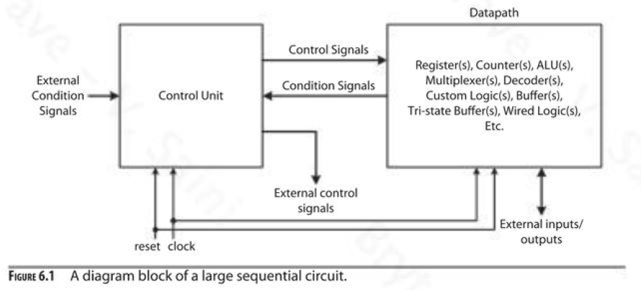

**Register transfer notation (RTN) is used to describe an operation of a data path:**

* Formally describes a data path operation
* Examples:

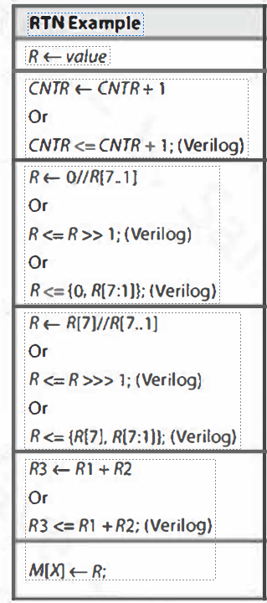

**Data path types:**

-Architecture of data path can be classified as single cycle, multiple cycles or pipelined.

-A single-cycled data path requires more hardware but a simpler control unit.

-A multicycle data path requires less hardware but generates results in several clock cycles.

-A pipelined data path also requires more hardware but can operate on multiple inputs concurrently.

-The single Data path contains two adders (+) modules and one adder/sub tractor (+/-) module.

-The single mode controls the functions of the adder/sub tractor modules.

-Time period is proportional to the propagation delay of the longest signal path that starts from the inputs of the first adder and ends at the input of the register.

--In general, a single cycle data path implements several simple and complex operations, its minimum clock would be proportional to the time required to complete most complex operations.

Sequential Circuit: Datapath ( Timing )

Tcq: Clock to queue

Tst (T setup time): is defined as the minimum amount of time before the clock’s active edge that the data must be stable for it to latch correctly.

Tcs: clock to skew

Thold or Th: Hold time is defined as the minimum amount of time after the clock’s active edge during which data must be stable.

* + Sequential circuit: single cycle data path: A + B + C + D or A + B + C – D
* Data path contains two adder modules and one adder/subtractor module
* The single mode controls the functions of the adder/subtractor modules

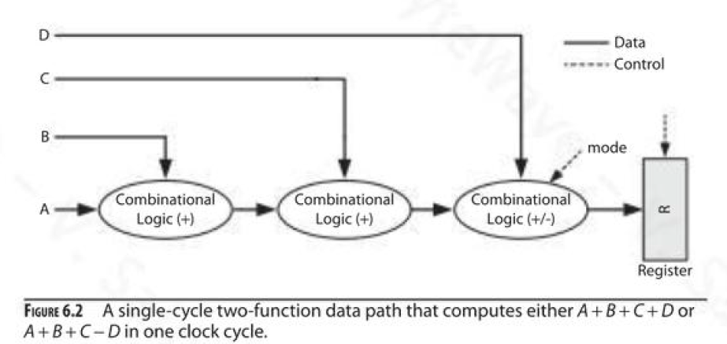

***Sequential circuit: Single cycle data path architecture***

-Data path that computes either the quantity

* + A + B + C + D or A + B + C – D

-Equation that estimates the minimum clock period (τ) required to run the data path

* + Add stands for Adder; Sub stands for subtractor
  + Δ is delta time delay from input to output

τs >= 2Δadd + Δadd/sub  + Tst +Tcq  + Tcs

τs = τ-single-cycle

***Sequential circuit: Multicycle data path architecture***

-Data path that computes either the quantity

* + A + B + C + D or A + B + C – D

-Equation that estimates the minimum clock period (τ) required to run the data path

* + Add stands for Adder; Sub stands for subtractor; Mux stands for Multiplexor
  + Δ is delta time delay from input to output

τm >= Δ mux1 + Δ add/sub + Δ mux2 + Tst +Tcq  + Tcs

τm = τ-multicycle

-A multicycle data path requires that a computation be divided and computed in steps.

-A multi cycle algorithm to implement R <­­­­---- A + B + C + D or A + B + C – D; (5 possible simple operations)

Cycle 1: R <­­­­----- A Cycle 2: R <­­­­----- R + B

Cycle 3: R <­­­­----- R + C Cycle 4: If mode == 0, then R <­­­­----- R + D; otherwise R <­­­­----- R – D

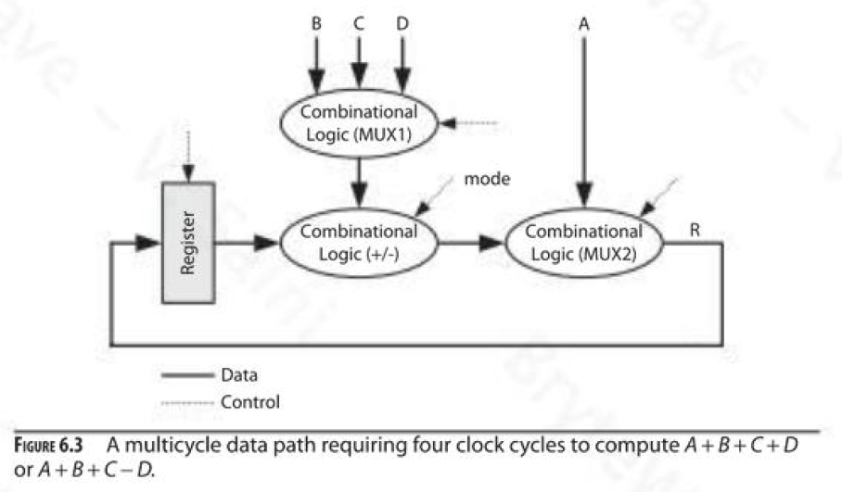

***Seq circuit: Pipelined Data path architecture***

-Data path that computes stream of quantities Ai + bi + Ci +/- Di

* Ai + bi + Ci +/- Di
* τ = represents minimum clock period for pipeline data path architecture
* Equation that estimates the minimum clock period (τ) required to run the data path
  + Add stands for Adder; Sub stands for subtractor; Mux stands for Multiplexor
  + Δ is delta time delay from input to output

τ p >= Δ add/sub + Tst +Tcq  + Tcs

τ -p = τ-pipeline

* Computing stream of quantities Ai + bi + Ci +/- Di.

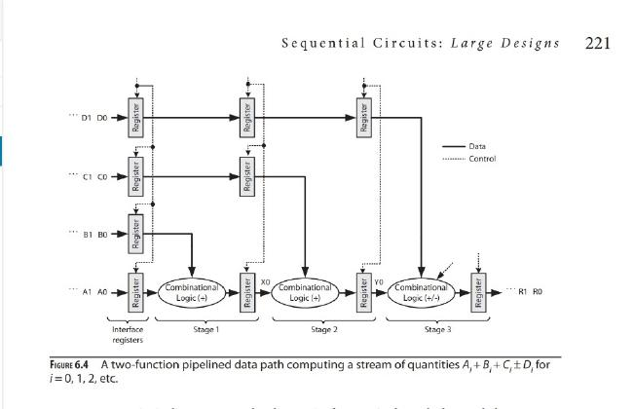

* Seq circuit: Pipelined Data path architecture (Cont)

Refer to Figure 6.5 -Horizontal Pipeline chart

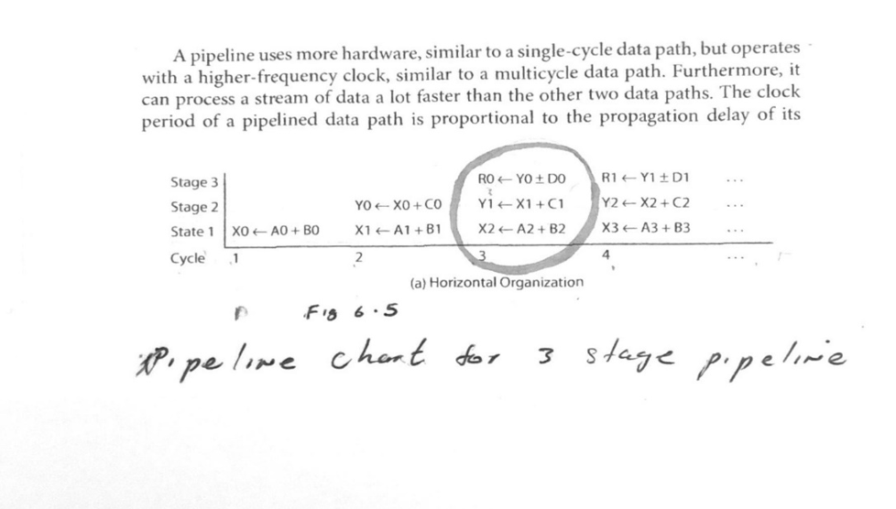

Refer to Figure 6.5 -Horizontal Pipeline chart (Cont)

* The pipeline chart in Fig. 6.5(a) has horizontal organization with clock cycles shown on the x-axis.
  + Pipeline chart illustrates various chart, does not include 1 cycle delay caused by interfacing registers
  + Has horizontal organization with clock cycles shown on x-axis.

**Sequential circuit: Pipeline performance**

* In the example, R0 being the first result, requires 3 clock cycles to complete. (Ignore 1 cycle for interface registers)
* After R0, R1, R2…..Rn each output requires 1 clock cycle to produce results.
* Reduces time required to compute N final results.
* K stage (linear) pipeline requires K cycles for output.
* Equation Eq6.4 estimates total time (Tpipeline) required to process stream size of N using K stage pipeline

Tpipeline = K * τp + (N-1)* τp (Eq 6.4)

* Estimates total time- Tsingle -cycle to process data stream of size N using single cycle data path.

TSingle-cycle = N * K * τp (Eq 6.5)

* Speed up is performance parameter that measures performance of faster system to a slower system.
* Defined as ratio of the time required by a slower system over faster system.
* Equation that defines speedup between a faster pipeline data path compared slower single cycle Datapath.

Speedup = Tsingle-cycle/Tpipeline = N * k * τp / k* τp + (n-1) * τp (eq. 6.6)

= N * K/ (K +N -1)

* Efficiency is performance parameter that measures how well a system’s resource’s are utilized.
* Overall efficiency of a system is defined as the ratio of it’s speedup to its maximum possible speedup.
* Efficiency = Speedup/K = N/ (k+N-1)
* As N approaches infinity, efficiency of pipeline approaches 100%.
* Throughput is performance parameter that measures a system’s rate of processing
* Indicates the # of items (N) performed per second
* Eq. 6.8 defines the throughput of a linear pipeline with k stages

Throughput = N/Tpipeline = N/[(k τ) + (N-1) * τ]

